COMSOL Ltd.  Park House, Castle Park  Cambridge CB3 0DU  Tel: 01223 451580  Web: https://uk.comsol.com  Blog: https://uk.comsol.com/blogs | Media Contact:  Ksenia Semina, UK Marketing Manager  ksenia@comsol.com  RF Module:  https://uk.comsol.com/rf-module

Enhanced Circuit Performance with Multiphysics Simulation
COMSOL delivers the latest tools to support microwave and RF engineers working on 5G, IoT, automotive radars and satellite communications.

CAMBRIDGE, UK (June 3, 2019) — COMSOL is excited to announce the latest advances in its COMSOL Multiphysics® software to support microwave and RF engineers working on 5G, IoT, automotive radars and satellite communications. With these tools, designers can model different PCB materials and study how they affect the performance of microwave and millimeter wave circuits. Several of the application examples to guide designers will be introduced at the International Microwave Symposium (IMS) 2019.

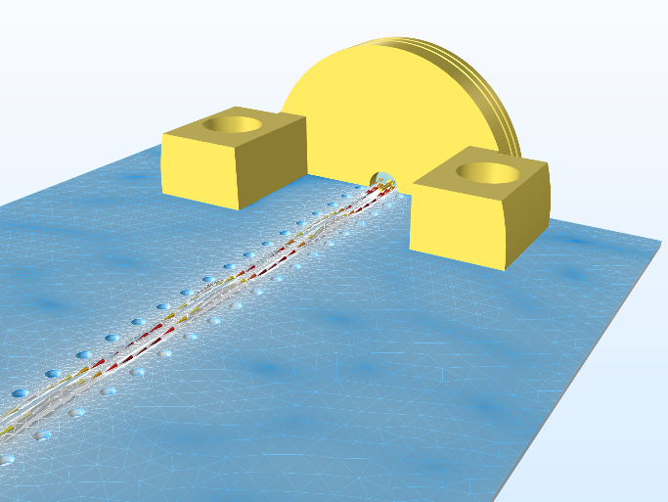
“We are particularly excited to demonstrate how to set up and run a simulation to design and evaluate a Grounded Coplanar Waveguide (GCPW) line,” said Jiyoun Munn, technical product manager of the RF Module at COMSOL. “Connectors and low loss materials are the key components across all electronic devices and systems. Their reliability is critical in circuits that transmit and receive information.”

The use of simulation to achieve low insertion loss and reliable circuit performance in a design, requires choosing accurate material properties such as relative dielectric constant and loss tangent, while also considering surface roughness effects in the computer model.
Grounded coplanar waveguide (GCPW) circuit with edge launch connector(s) created using COMSOL Multiphysics® software. Electric field norm is visualised in dB scale.

“As the frequency increases, maintaining the impedance become more complex, as small quirks arising from the geometry or selected materials can be magnified,” explains Bill Rosas, Cofounder of Signal Microwave. “Simulation allows us to ensure that these critical pieces of RF infrastructure are optimised for 5G communications.”

Designing components ready for 5G, IoT, automotive radars and satellite communications will require multiphysics modelling. Using COMSOL Multiphysics microwave and RF designers can couple electromagnetic simulations with heat transfer, structural mechanics, fluid flow and other physical phenomena, allowing them to represent coupled physics effects as they would occur in the real world. That means being able to accurately investigate designs and fully benefit from the virtual prototyping capabilities multiphysics simulation offers.

To learn more about COMSOL Multiphysics and its RF module visit: https://uk.comsol.com/rf-module

To schedule an interview with Jiyoun Munn, technical product manager of the RF Module at COMSOL at IMS please connect with Ksenia Semina, ksenia@comsol.com.

About COMSOL
COMSOL is a global provider of simulation software for product design and research to technical enterprises, research labs, and universities. Its COMSOL Multiphysics® product is an integrated software environment for creating physics-based models and simulation applications. A particular strength is its ability to account for coupled or multiphysics phenomena. Add-on products expand the simulation platform for electromagnetics, structural, acoustics, fluid flow, heat transfer and chemical applications. Interfacing tools enable the integration of COMSOL Multiphysics® simulations with all major technical computing and CAD tools on the CAE market. Simulation experts rely on COMSOL Compiler™ and COMSOL Server™ to deploy applications to their design teams, manufacturing departments, test laboratories and customers throughout the world. Founded in 1986, COMSOL has 19 offices worldwide and extends its reach with a network of distributors.
~
COMSOL, COMSOL Multiphysics, LiveLink, COMSOL Compiler, COMSOL Runtime, and COMSOL Server are either registered trademarks or trademarks of COMSOL AB. For other trademark ownership, see uk.comsol.com/trademarks.

