COMSOL Ltd.  Park House, Castle Park  Cambridge CB3 0DU  Tel: 01223 451580 | Media Contact:  Ksenia Semina, UK Marketing Manager  ksenia@comsol.com  Web: uk.comsol.com  Blog: uk.comsol.com/blogs  Worldwide Offices: https://www.comsol.com/contact

Online COMSOL Conference 2020 Europe Announced for 14-15 October

COMSOL is announcing the COMSOL Conference 2020 Europe, to be held online for the first time, on 14-15 October and is inviting abstract submissions for posters and papers, with the final deadline of 31st of July.

CAMBRIDGE, UK (4 June, 2020) — COMSOL is pleased to announce the COMSOL Conference 2020 Europe, to be held on 14-15 October, 2020. The annual COMSOL Conference, a meeting focusing on advancing skills and furthering collaboration among engineers and scientists in the area of numerical simulation, will for the first time run online. Participants, from the comfort of their own workstations, will be able to experience event highlights, including:

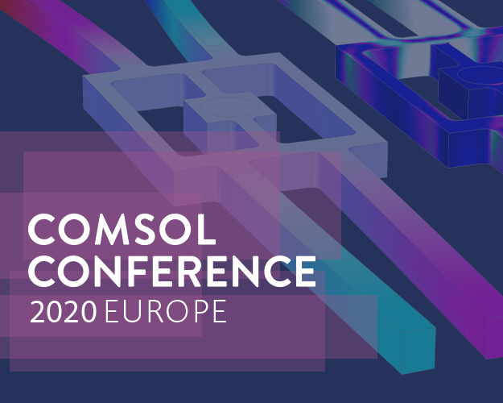
- Invited speakers from industry and academia sharing their experiences using multiphysics modelling and simulation apps
- COMSOL keynotes featuring news and software product announcements
- User presentations showcasing research achievements and innovative design projects
- Panel discussions on the stakes of simulation and simulation in the energy and biomedical fields
- Tech Cafés - interactive sessions where software developers and technical product managers take modelling questions directly from COMSOL users
- Minicourses offering learning opportunities for any level of simulation expertise, from introductory to advanced
- Virtual exhibition and poster session

"With recent travel restrictions and social distancing in mind, moving the conference online this year is clearly the best option," says Eric Favre, Managing Director at COMSOL France. He adds, "The COMSOL Conference will be easy to join online, without travel time or time away from home. We believe that the online conference will be attractive to many, as it will also be easier to fit with a busy schedule and other obligations. As we will miss out on in-person meetings, we will be placing extra emphasis on providing interactive, small group sessions and one-on-one discussions. An added benefit is that we will also have access to COMSOL's global pool of engineers, as it will be equally easy for them to join the conversations, from anywhere."

For event details and registration, please visit: COMSOL Conference 2020 Europe

Abstract Submission for Papers and Posters

The Programme Committee for the COMSOL Conference 2020 Europe is now inviting abstract submissions for posters and papers on simulation work and applications from users of COMSOL Multiphysics® to present at the conference.

The papers and posters accepted for presentation will later be shared with the community through the open-access Technical Papers and Presentations database, with a global reach.

The abstract submission deadlines for the COMSOL Conference 2020 Europe are: Early Bird submission by 3rd of July; Final Abstract submission by 31st of July. For information and guidelines for abstract submission, please visit: Call for Papers and Posters.

The conference presentations have a broad scope and the call for papers includes topics such as:

- AC/DC electromagnetics
- Acoustics and vibrations
- Batteries, fuel cells and electrochemical processes
- Bioscience and bioengineering
- Chemical reaction engineering
- Computational fluid dynamics
- Electromagnetic heating
- Geophysics and geomechanics
- Heat transfer and phase change
- MEMS and nanotechnology
- Metal Processing
- Microfluidics
- Multiphysics
- Optics, photonics and semiconductors
- Optimisation and inverse methods
- Particle tracing
- Piezoelectric devices
- Plasma physics
- Porous Media Flow
- RF and microwave engineering
- Simulation methods and teaching
- Structural mechanics and thermal stresses
- Transport phenomena

About COMSOL

COMSOL is a global provider of simulation software for product design and research to technical enterprises, research labs and universities. Its COMSOL Multiphysics® product is an integrated software environment for creating physics-based models and simulation apps. A particular strength is its ability to account for coupled or multiphysics phenomena. Add-on products expand the simulation platform for electromagnetics, structural, acoustics, fluid flow, heat transfer and chemical applications. Interfacing tools enable the integration of COMSOL Multiphysics® simulations with all major technical computing and CAD tools on the CAE market. Simulation experts rely on COMSOL Compiler™ and COMSOL Server™ to deploy applications to their design teams, manufacturing departments, test laboratories and customers throughout the world. Founded in 1986, COMSOL has 19 offices worldwide and extends its reach with a network of distributors.
~

COMSOL, COMSOL Multiphysics, COMSOL Compiler, COMSOL Runtime and COMSOL Server are either registered trademarks or trademarks of COMSOL AB. COMSOL trademark guidelines are available at https://uk.comsol.com/trademarks.

