COMSOL Ltd.  Park House, Castle Park  Cambridge, CB3 0DU, UK  Phone: +44 (0) 1223 451580  Web: uk.comsol.com  Blog: uk.comsol.com/blogs | Media Contact:  Katerina Pichugina, Marketing Manager  ekaterina@comsol.com  Attend a COMSOL Days event near you:  uk.comsol.com/comsol-days

COMSOL Days 2018 Hits the Road in Edinburgh this March

COMSOL Days brings together engineers and scientists for a day of minicourses and talks on multiphysics modelling and simulation apps.

CAMBRIDGE, UK (February 16, 2018) — COMSOL is excited to announce the COMSOL Days 2018 schedule of events for the worldwide tour. COMSOL Days offer a full day program with technical presentations and breakout sessions focusing on major application areas of multiphysics simulation. COMSOL Days are free-of-charge, welcoming engineers and researchers to connect with COMSOL software users, get inspired by invited speakers, and meet with COMSOL technical staff. The events begin with an overview of the COMSOL Multiphysics® software and how apps can be used to spread simulation throughout an organisation. The program offers different tracks and learning opportunities for new and experienced simulation users on a variety of topics and disciplines. Attendees at a COMSOL Day event will leave with the knowledge of how to use simulation to boost productivity and optimise design and research methods.

“COMSOL Days is an investment we make into building the user community” says Jeff Hiller, VP of Sales, COMSOL, Inc. “We are able to bring together technical specialists within our organisation and partner them with current and prospective customers across the globe. Here they get to share best practices in multiphysics simulation and app development and deployment.”

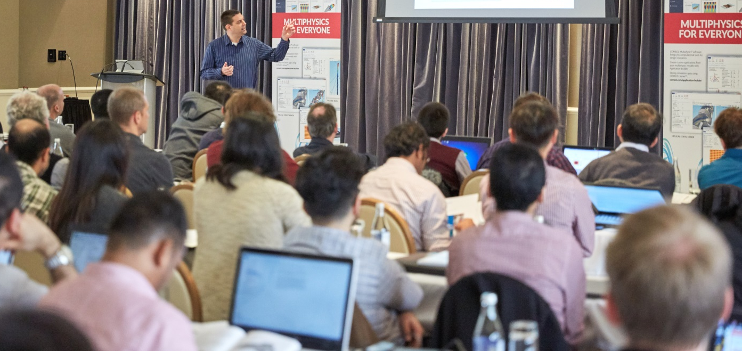

The COMSOL Days worldwide cities include:
- Paris, France, March 6  - Edinburgh, UK, March 8  - Grenoble, France, March 13  - Bethesda, MD, US, April 5  - Munich, Germany, April 12  - Stockholm, Sweden, April 12  - Houston, TX, US, April 19  - Montreal, Quebec, May 2  - Brescia, Italy, May 9  - Detroit, MI, US, May 10  - San Jose, CA, US, May 16 | - Orange County, CA, US, May 17  - Goteborg, Sweden, May 22  - Gottingen, Germany, May 29  - Rome, Italy, June 5  - Stuttgart, Germany, June 14  - Columbus, OH, US, June 21  - Lund, Sweden, September 25  - Boston, MA, US, TBD  - Eindhoven, Netherlands, TBD  - Rio De Janeiro, Brazil, TBD  - Saint Petersburg, Russia, TBD
For more details about COMSOL Days and to register, visit: uk.comsol.com/comsol-days.
About COMSOL
COMSOL is a global provider of simulation software for product design and research to technical enterprises, research labs, and universities. Its COMSOL Multiphysics® product is an integrated software environment for creating physics-based models and simulation apps. A particular strength is its ability to account for coupled or multiphysics phenomena. Add-on products expand the simulation platform for electromagnetics, structural, acoustics, fluid flow, heat transfer, and chemical applications. Interfacing tools enable the integration of COMSOL Multiphysics® simulations with all major technical computing and CAD tools on the CAE market. Simulation experts rely on the COMSOL Server™ product to deploy apps to their design teams, manufacturing departments, test laboratories, and customers throughout the world. Founded in 1986, COMSOL employs more than 450 people in 20 offices worldwide and extends its reach with a network of distributors.
~
COMSOL, COMSOL Multiphysics, LiveLink, and COMSOL Server are either registered trademarks or trademarks of COMSOL AB. For other trademark ownership, see www.comsol.com/trademarks.

